# **Movie Ticket Reservation System (MTRS) - Database Design Documentation**

## **1. Business Problem Statement**

The Movie Ticket Reservation System shall automate and facilitate movie ticket reservations. It shall provide the facility to the end-users of the system to search for available movies, select a show, choose seats, pay for it, and notify them of their purchase. The system shall also support administrative features like movie, theatre, and discount management.

## **2. Entity Descriptions and Relationships**

**2.1 Movies**

* **Primary Key:** MovieID
* **Attributes:** Title, Genre, Language, Rating, Duration, Description
* **Relationships:**

**One-to-Many:** One movie can have multiple shows

**2.2 Shows**

* **Primary Key:** ShowID
* **Foreign Keys:** MovieID, TheaterID
* **Attributes:** ShowDate, ShowTime, TicketPrice
* **Relationships:**

**One-to-Many:** Each show belongs to one movie but can have multiple seat reservations

**Many-to-One:** Linked to the Movies entity via MovieID

**One-to-Many:** One show can have multiple seats

**2.3 Seats**

* **Primary Key:** SeatID
* **Foreign Key:** ShowID Attributes: SeatNumber, Status (Available/Reserved)
* **Relationships:**

**Many-to-One:** Linked to the Shows entity via ShowID

**2.4 Users**

* **Primary Key:** UserID
* **Attributes:** Name, Email, PhoneNumber, Password, Address, Payment Information
* **Relationships:**

**One-to-Many:** One user can make multiple bookings

**One-to-Many:** One user can receive multiple notifications

**One-to-Many:** One user can submit multiple reviews

**2.5 Bookings**

* **Primary Key:** BookingID
* **Foreign Keys:** UserID, ShowID
* **Attributes:** BookingDate, PaymentStatus, TotalAmount
* **Relationships:**

**Many-to-One:** Linked to the Users entity via UserID

**Many-to-One:** Linked to the Shows entity via ShowID

**2.6 Payments**

* **Primary Key:** PaymentID
* **Foreign Key:** BookingID
* **Attributes:** PaymentDate, PaymentAmount, PaymentStatus, PaymentMethod
* **Relationships:**

**One-to-One:** One payment is associated with one booking

**2.7 Theaters**

* **Primary Key:** TheaterID
* **Attributes:** TheaterName, Address, Capacity, Contact Information
* **Relationships:**

**One-to-Many:** One theater can have multiple shows

**2.8 Notifications**

* **Primary Key:** NotificationID
* **Foreign Key:** UserID
* **Attributes:** Message, NotificationType, ReadStatus
* **Relationships:**

**Many-to-One:** Linked to the Users entity via UserID

**2.9 Search History**

* **Primary Key: SearchID**
* **Foreign Key: UserID**
* **Attributes: SearchQuery, SearchDate**
* **Relationships:**

**Many-to-One**: Linked to the Users entity via UserID

**2.10 Reviews**

* **Primary Key:** ReviewID
* **Foreign Keys:** UserID, MovieID
* **Attributes:** Rating, Comment
* **Relationships:**

**Many-to-One:** Linked to the Users entity via UserID

**Many-to-One:** Linked to the Movies entity via MovieID.

**2.11 Discounts/Offers**

* **Primary Key:** OfferID
* **Attributes:** OfferName, Discount Percentage, StartDate, EndDate
* **Relationships:**

**One-to-Many:** Offers can apply to multiple users

**Entity - Relationship Diagram for Movie Ticket Reservation System**

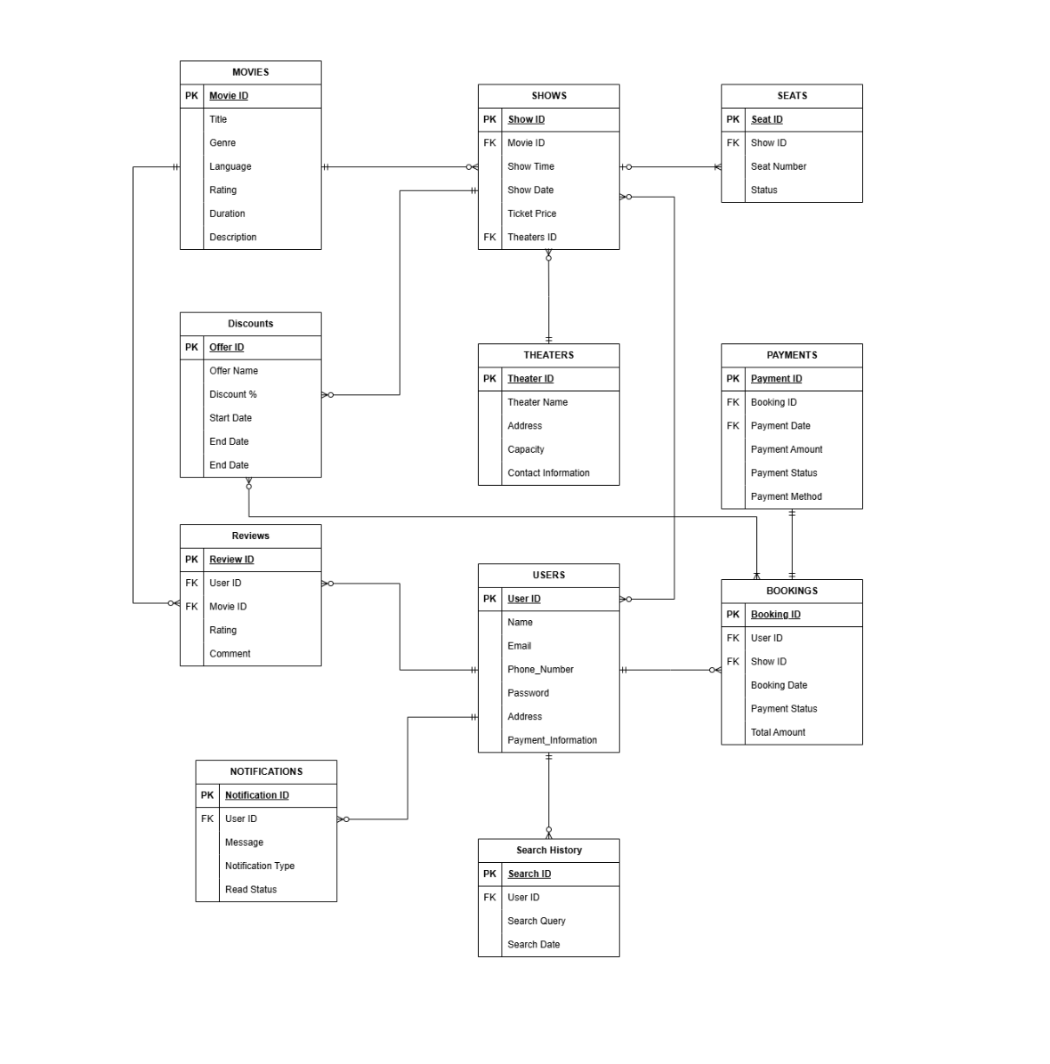

## **3. ERD Relationship Overview**

### **Key Relationships:**

* **Movies ↔ Shows:** One movie can have multiple shows. (One-to-Many)
* **Shows ↔ Seats:** Each show manages multiple seats. (One-to-Many)
* **Users ↔ Bookings:** A user can have multiple bookings. (One-to-Many)
* **Bookings ↔ Payments:** Each booking has one payment. (One-to-One)
* **Theaters ↔ Shows:** Each theater can host multiple shows. (One-to-Many)
* **Users ↔ Notifications:** Users can receive multiple notifications. (One-to-Many)
* **Users ↔ Reviews:** Users can submit multiple reviews. (One-to-Many)

**4. Key Design Decisions**

* **Seat Reservation:** Each seat is uniquely assigned per show to avoid overbooking issues.
* **User Role Management:** The system differentiates between users and administrators for better control.
* **Payment Handling:** A single payment entry per booking ensures clear tracking of financial transactions.
* **Notifications:** The system provides a mechanism for informing users about their bookings, payment updates, and other relevant activities.
* **Reviews and Ratings**: Users can provide feedback on movies to enhance engagement and improve recommendations.
* **Discount System:** The discount entity allows the introduction of promotions and special offers on specific shows.